Εγκατασταση usb συνδεσης με την εφαρμογή

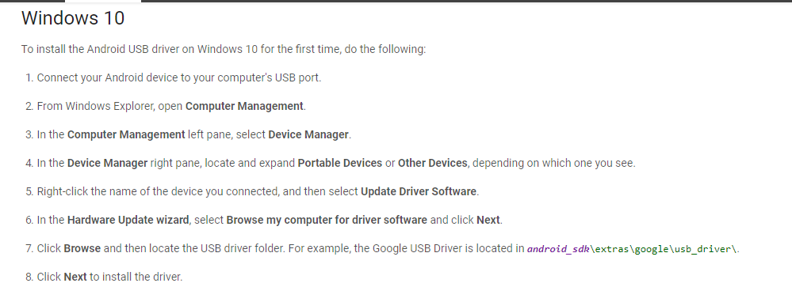

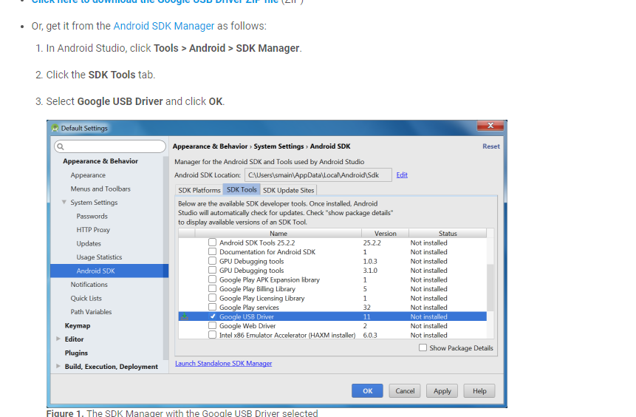

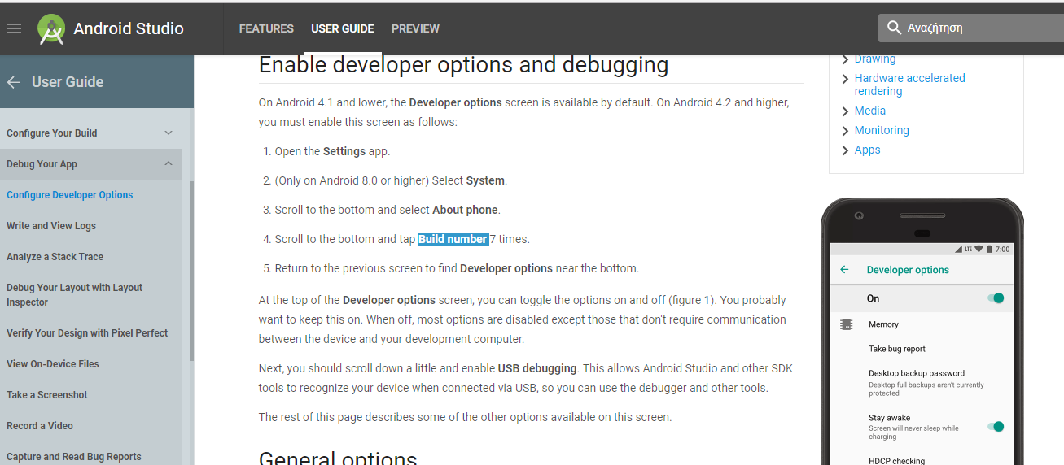

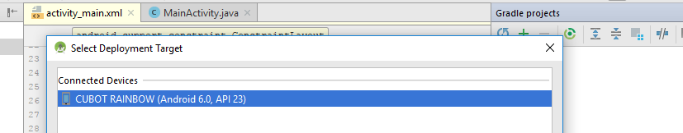

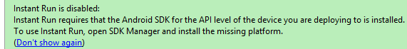

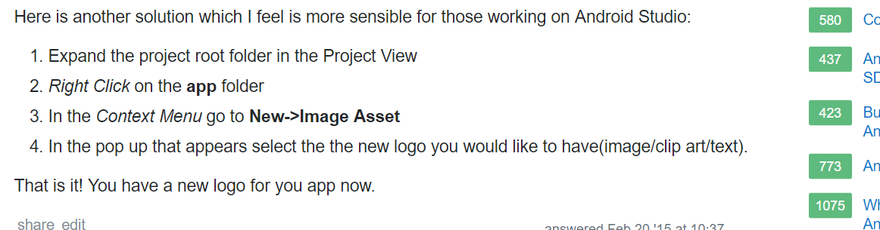

<https://www.androidtutorialpoint.com/wp-content/uploads/2016/07/MainActivity.txt>

<https://www.androidtutorialpoint.com/intermediate/google-maps-search-nearby-displaying-nearby-places-using-google-places-api-google-maps-api-v2/#comments>

**Γενικά πρώτα built->clean και μετά debug without instant run**

**connect android from different wifi ip:**

[**https://stackoverflow.com/questions/4779963/how-can-i-access-my-localhost-from-my-android-device/15864222#15864222**](https://stackoverflow.com/questions/4779963/how-can-i-access-my-localhost-from-my-android-device/15864222#15864222)

portable solution with ngrok (any OS with node or npm)

If you don't mind exposing your project with a temporary domain you can use ngrok. Lets say I have an app that runs on localhost:9460

npm install ngrok -g

ngrok http 9460

This will give me:

Session Status online

Update update available (version 2.2.8, Ctrl-U to update)

Version 2.2.3

Region United States (us)

Web Interface http://127.0.0.1:4040

Forwarding http://f7c23d14.ngrok.io -> localhost:9460

Forwarding https://f7c23d14.ngrok.io -> localhost:9460

Connections ttl opn rt1 rt5 p50 p90

0 0 0.00 0.00 0.00 0.00

I can now reach https://f7c23d14.ngrok.io as a way to remotely view localhost. This is great to share design work or progress with clients

**mysign from:**

[**http://www.codebind.com/android-tutorials-and-examples/android-mysql-database-tutorial-android-login-php-mysql/**](http://www.codebind.com/android-tutorials-and-examples/android-mysql-database-tutorial-android-login-php-mysql/)

**Async<String,void,String>**

**Params**, the type of the parameters sent to the task upon execution.

**Progress**, the type of the progress units published during the background computation.

**Result**, the type of the result of the background computation.

Now my understanding in simple words:

**Params:** (in your case String) is the parameter that the AsyncTask takes. You have to pass this when you call execute method

**Progress:** (in your case Void) is the type of progress. Void means you are not using it. If it is say, Integer, you could've used values like 10, 20, 30... and use these to show a progress bar on screen.

**Result:** (in your case String) is what the AsyncTask returns as the result. You are returning a String. You can return any Object you want.

Το χρησιμοποιουμε καλωντας αυταματα την do in background() me to execute()

**Retrieving data from database and displaying it in android app:**

[**https://www.simplifiedcoding.net/retrieve-data-mysql-database-android/**](https://www.simplifiedcoding.net/retrieve-data-mysql-database-android/)

* [**https://github.com/SumitRajpal/MySqlAndroid**](https://github.com/SumitRajpal/MySqlAndroid)

**json:** [**https://www.w3schools.com/js/js_json_intro.asp**](https://www.w3schools.com/js/js_json_intro.asp)

**session shared preferences (login,logout,amka)**

[**https://www.androidhive.info/2012/08/android-session-management-using-shared-preferences/**](https://www.androidhive.info/2012/08/android-session-management-using-shared-preferences/)

**get current phone number**

[**https://stackoverflow.com/questions/2480288/programmatically-obtain-the-phone-number-of-the-android-phone**](https://stackoverflow.com/questions/2480288/programmatically-obtain-the-phone-number-of-the-android-phone)

**EIKONA FIRST AID:** [**https://nl.dreamstime.com/stock-afbeelding-de-pleisters-van-het-rode-kruis-image4525911**](https://nl.dreamstime.com/stock-afbeelding-de-pleisters-van-het-rode-kruis-image4525911)

<**TextView  
 android:id="@+id/textView9"  
 android:layout_width="wrap_content"  
 android:layout_height="wrap_content"  
 android:layout_alignParentLeft="true"  
 android:layout_alignParentStart="true"  
 android:background="@color/colorPrimary"  
 android:backgroundTint="@color/colorAccent"  
 android:text="Επέλεξε κάποιο πρόσωπο(γιατρό, φίλο, γονιό) ο οποίος θα ειδοποιηθει άμμεσα, μέσω της κινητής του συσκευής, για την τοποθεσία που βρίσκεσαι σε περίπτωση έκτακτης ανάγκης(πατώντας το κουμπί SOS που βρίσκεται στο MENU)"  
 android:textColor="@color/cast_expanded_controller_background_color"** />  
  
 <**TextView  
 android:id="@+id/textView8"  
 android:layout_width="wrap_content"  
 android:layout_height="wrap_content"  
 android:layout_alignParentLeft="true"  
 android:layout_alignParentStart="true"  
 android:layout_below="@+id/textView9"  
 android:text="Αριθμός Προσώπου Έκτακτης Κλήσης"  
 tools:layout_editor_absoluteX="0dp"  
 tools:layout_editor_absoluteY="96dp"** />  
  
  
 <**EditText  
 android:id="@+id/editText3"  
 android:layout_width="wrap_content"  
 android:layout_height="wrap_content"  
 android:layout_below="@+id/textView8"  
 android:ems="10"  
 android:inputType="phone"  
 tools:layout_editor_absoluteX="0dp"  
 tools:layout_editor_absoluteY="115dp"** />  
  
 <**EditText  
 android:id="@+id/editText4"  
 android:layout_width="151dp"  
 android:layout_height="130dp"  
 android:layout_below="@+id/textView10"  
 android:ems="10"  
 android:inputType="textPersonName"  
 android:text="Ιστορικό "  
 tools:layout_editor_absoluteX="0dp"  
 tools:layout_editor_absoluteY="270dp"** />  
  
 <**TextView  
 android:id="@+id/textView10"  
 android:layout_width="wrap_content"  
 android:layout_height="wrap_content"  
 android:layout_below="@+id/textView3"  
 android:text="Δώσε πληροφορίες σχετικά με την υγεία σου και το ιστορικό σου.  
(αλλεργίες, χρόνιες παθήσεις κτλ)"  
 android:textColor="@color/cast_expanded_controller_background_color"  
 tools:layout_editor_absoluteX="0dp"  
 tools:layout_editor_absoluteY="217dp"** />  
  
 <**Button  
 android:id="@+id/button4"  
 android:layout_width="wrap_content"  
 android:layout_height="wrap_content"  
 android:background="@android:color/holo_green_dark"  
 android:text="Προσθήκη"  
 android:textColor="@android:color/background_light"  
 tools:layout_editor_absoluteX="160dp"  
 tools:layout_editor_absoluteY="389dp"** />

**try** {  
  
*// Getting address from found locations.* Geocoder geocoder;  
 List<Address> addresses;  
 geocoder = **new** Geocoder(**this**, Locale.*getDefault*());  
 addresses = geocoder.getFromLocation(location.getLatitude(), location.getLongitude(), 1);  
   
   
 **CityName** = addresses.get(0).getLocality();  
 **CountryName** = addresses.get(0).getCountryName();  
   
 **line** = addresses.get(0).getAddressLine(0);  
 *// you can get more details other than this . like country code, state code, etc.* Toast.*makeText*(getApplicationContext(), **"cityName: "** + **CityName**, Toast.***LENGTH_SHORT***).show();  
 Toast.*makeText*(getApplicationContext(), **"countryName: "** + **CountryName**, Toast.***LENGTH_SHORT***).show();  
   
 Toast.*makeText*(getApplicationContext(), **"line: "** + **line**, Toast.***LENGTH_SHORT***).show();  
 }  
 **catch** (Exception e)  
 {  
 e.printStackTrace();  
 }

</**activity**>  
 <**service android:name=".HeadlessSmsSendService"  
 android:permission="android.permission.SEND_RESPOND_VIA_MESSAGE"  
 android:exported="true"** >  
 <**intent-filter**>  
 <**action android:name="android.intent.action.RESPOND_VIA_MESSAGE"** />  
 <**category android:name="android.intent.category.DEFAULT"** />  
 <**data android:scheme="sms"** />  
 <**data android:scheme="smsto"** />  
 <**data android:scheme="mms"** />  
 <**data android:scheme="mmsto"** />  
 </**intent-filter**>  
 </**service**>

**Permitiion**

[**https://inthecheesefactory.com/blog/things-you-need-to-know-about-android-m-permission-developer-edition/en**](https://inthecheesefactory.com/blog/things-you-need-to-know-about-android-m-permission-developer-edition/en)

[**https://stackoverflow.com/questions/40950062/how-to-connect-android-app-with-local-server-xampp**](https://stackoverflow.com/questions/40950062/how-to-connect-android-app-with-local-server-xampp)

**app store :** [**https://developer.android.com/studio/publish/index.html**](https://developer.android.com/studio/publish/index.html)

[**https://stackoverflow.com/questions/40950062/how-to-connect-android-app-with-local-server-xampp**](https://stackoverflow.com/questions/40950062/how-to-connect-android-app-with-local-server-xampp)

**for access from any deviceDocuments\ ngrok http 80 , not close the cmd**

**download and open pdf examination:**

[**https://androidknowledgeblog.wordpress.com/2016/04/02/download-pdf-from-server-android/**](https://androidknowledgeblog.wordpress.com/2016/04/02/download-pdf-from-server-android/)

**διαγνωστικές**

**https://www.doctoranytime.gr/diagnostikes-eksetaseis**

[**http://www.codingcage.com/2014/12/file-upload-and-view-with-php-and-mysql.htm**](http://www.codingcage.com/2014/12/file-upload-and-view-with-php-and-mysql.htm)

WebView webView = (WebView) findViewById(R.id.***my_webview***);  
WebSettings webSettings = webView.getSettings();  
webView.getSettings().setJavaScriptEnabled(**true**);  
webView.setWebViewClient(**new** MyWebViewClient());  
webView.addView(webView.getZoomControls());  
  
webView.loadUrl(**"http://docs.google.com/gview?embedded=true&url=http://myurl.com/demo.pdf"**);

**l**

<https://erasmusintern.org/traineeship/it-design>

<https://erasmusintern.org/traineeship/ict-intern>

* <https://erasmusintern.org/traineeship/web-developer-intern-barcelona-3-12-months>

-<https://erasmusintern.org/traineeship/business-intelligence-intern-multinational-company-barcelona-summer-2018erasmus-grant>

<https://erasmusintern.org/traineeship/internship-web-development-0>

<https://erasmusintern.org/traineeship/stage-web-development-0>

* <https://erasmusintern.org/traineeship/web-development-intern-4>

<https://erasmusintern.org/traineeship/internship-web-development-0>

<https://erasmusintern.org/traineeship/development-software-and-hardware-intern>

<https://erasmusintern.org/traineeship/stage-web-development-2>

<https://erasmusintern.org/traineeship/paid-350%E2%82%ACmonth-it-internship-marbella>

<https://erasmusintern.org/traineeship/internship-development-software-embedded-systems>

Dear Sir or Madam:

With this letter, I would like to express my interest in working with you as Erasmus + student.

I only have six lessons left for my degree at the Department of Information and Communication System of the University of Aegean, so probably I will be graduated since September.

Dear Sir or Madam,

With this letter, I would like to express my interest in working with you as Erasmus + student.

I only have six lessons left for my degree at the Department of Information and Communication System of the University of Aegean, so I probably will be graduated since September 2018.

I have decided to apply for this job because I am sure it would strongly enrich my passion for learning more things every day. Moreover, I want to enter in the "real" world and work hard to accomplish any goals for any difficult project, that will be given to me.

During my prior studies, I have found out, that I would like to specialize in programming, Web and Android development and designing and I am able to learn fast new programming languages or ways for better solutions. So, when I I read the responsibilities of your internship, I thought that you will give me the possibilities for further expand those at my university. I would take modules focusing on all of your responsibilities and I believe that I fulfill your requirements.

Thank you for considering my request. I will be glad if you check my CV. I look forward to your positive response.

Yours faithfully,  
Martha Todi

* https://docs.google.com/forms/d/e/1FAIpQLSfYz7wHy2gUKTdiiW5BunjcUq3IZ5eKqchU12wqguRcyi_BIA/viewform

<https://erasmusintern.org/traineeship/it-design>

**Έχω προσφορά από:**

* **TEKshop (porogalia)**
* **We hiring( γραναδα-ισπανια)** **https://erasmusintern.org/traineeship/it-design**
* **ICT Intern(Barcelona)**

**Kai mia allh prasinh**